Test Summary for Lab 6

(Shruti Ratna Charugulla)

Purpose 1

Overview of SideeX 1

Tests Executed 2

Automation Testing – Record and Playback 2

Metrics 2

Test Cases 2

Defects 2

Test Environment and Tools 2

Exit Criteria 2

Conclusion/Sign off 2

## Purpose

This report provides a summary of the testing conducted to verify that proper page was loaded by verifying the title of the web page.

## Overview of SideeX

SideeX is an open source record-playback-style web application testing tool. It is an extended version of Selenium IDE with a number of expanded automation capabilities. It runs as an extension in both Chrome and Firefox browsers. Below is a snapshot of the SideeX’ graphical user interface.

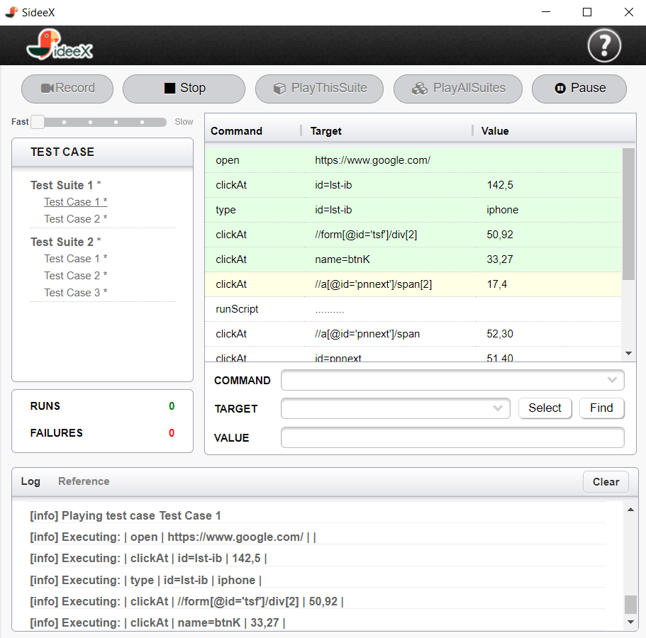

## Tests Executed

### Automation Testing – Record and Playback

The test case listed below was recorded using the record feature in SideeX application:

#### Test Case 1:

1. Navigate to the webpage “[www.austincc.edu/wtucker](http://www.austincc.edu/wtucker).”
2. Left Click on “Personal Biography” in the middle of the displayed information.
3. Navigate to the SideeX command line and left click on the X, then scroll down.
4. Left click on “verify title”, and in the “Value” field type “Bill Tucker’s Biography”.

The test case was saved into a Test suite with the name –“Lab 6 – Shruti Charugulla” and then the test suite was played back to verify if the test case was executed successfully.

## Metrics

### Test Cases

|  |  |  |  |
| --- | --- | --- | --- |
| Test Cases Planned | Test Cases Executed | TCs Passed | TCs Failed |
| 1 | 1 | 1 | 0 |

### Defects

None

## Test Environment and Tools

Below is a table that includes a brief overview of the software and hardware setups used to execute the test cases described in this report.

|  |  |
| --- | --- |
| Automation testing tool | SideeX |
| Computer hardware | 2.3 GHz Intel Core i5, 4GB RAM |
| OS | OS X El Capitan Version 10.11.1 |

## Exit Criteria

* The planned test case needs to be passed.
* No critical defects found.
* The recorded test suite successfully played back.

## Conclusion/Sign off

All exit criteria were met and satisfied.